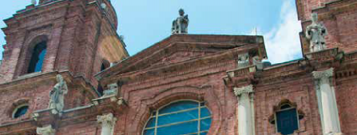

ASHEVILLE ROAD SCHOLAR REGISTRATION FORM

NAME_____________________________________________________
EMAIL_____________________________________________________
MAILING ADDRESS___________________________________________
PHONE NUMBER____________________________________________
____SINGLE ROOM ____DOUBLE ROOM
IF DOUBLE: NAME OF PERSON SHARING ROOM___________________________________________
EMAIL_________________________________________________________________________
MAILING ADDRESS_______________________________________________________________
PHONE NUMBER________________________________________________________________

CHECK INCLUDED FOR $150* MADE PAYABLE TO ASTEF. CHECK #____________________

*$50 IS A TAX-DEDUCTIBLE DONATION TO ASTEF.
THE REMAINING $100 GOES TOWARDS YOUR BALANCE.
ONCE YOU HAVE ENROLLED, YOUR INFORMATION WILL BE SHARED WITH ROAD SCHOLAR.
THEY WILL THEN COMMUNICATE WITH YOU DIRECTLY.

THANK YOU FOR SUPPORTING ASTEF!
If you have any questions about the trip or registration, email Dr. Barbara Derrick at president@astef.org. If you would like to speak to Barbara, include the best number where you can be reached in the subject line.

