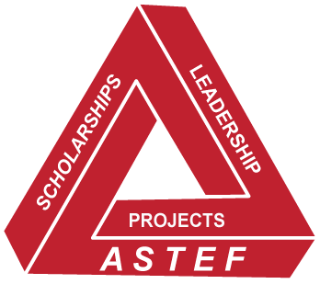
2021 ASPIRING EDUCATOR GRANT APPLICATION
ALPHA STATE TEXAS EDUCATIONAL FOUNDATION (ASTEF)
Grant Year: June 1, 2021 through May 31, 2022

IMPORTANT NOTICE
Review and follow the Aspiring Educator Grant Guidelines. Applications that are incomplete, missing the required letters of recommendation and/or transcripts, or that are postmarked (electronically or postal service) after March 1, 2021, will not be considered. Proofread your application carefully before submitting. No screen shots will be accepted.

Grant applied for – select one: 3-hour 6-hour Alternative Teacher Certification

Personal Data:

Have you previously received an Aspiring Educator Grant? Yes No If yes, when? ________________

Name____________________________________________________________________________________________
Last First Middle Maiden

Mailing Address____________________________________________________________________________________
Street or Box Number City Zip

Telephone _____________________________________ Personal Email _____________________________________
Home Cell

Current Employer (if applicable)_______________________________________________________________________

Are you a DKG collegiate member? Yes No

If yes, date of induction ________________ Name and Location of Chapter ________________________________

Goals/Purpose of Study:
Tell us why you want to be a teacher. Please be as specific as possible using the space provided.

Goals/Purpose of Study (continued)

Upon completion of your teacher certification, where do you aspire to teach? __________________________________

In what grade level(s) and/or subject(s) do you aspire to teach? _____________________________________________

In the table below, provide the colleges/universities where you plan to pursue your studies, the location(s), and projected dates of enrollment. Attach a copy of your Degree/Certification Plan (if available).

College/University
Location
Dates of Enrollment

In what month and year do you expect to complete your bachelor’s degree and/or teacher certification? ___________________________________

Educational Background (Attach a transcript for each of the below. Unofficial transcripts are acceptable.)

 | Name of Institution | Location | Dates Attended | Graduated Y/N | College Hours Received
High School
College/University
College/University
Current Program |  |  |  | N/A

By typing your name below, you are certifying you have read the Aspiring Educator Grant Guidelines and that the information provided is true and correct.

Name of Applicant: |  | Date:

Name of Sponsoring Texas DKG Member: |  | Chapter Name:
Personal E-mail: |  | Texas DKG  Area No.:
Telephone: |  | Date:

Submit complete application package, including the application, letters of recommendation, transcripts, degree/certification plan (if applicable), and proof of acceptance to an alternative teacher certification program, if applicable, electronically (preferably) to:
aspiringedu@astef.org

Or by mail to: Cindy Neander
3004 High Chaparral Drive
Flower Mound, Texas 75022

All application materials must be submitted/postmarked by March 1, 2021

