In February, a short program was presented to Theta Sigma members, Area 3, on ASTEF: Alpha State Texas Educational Foundation.
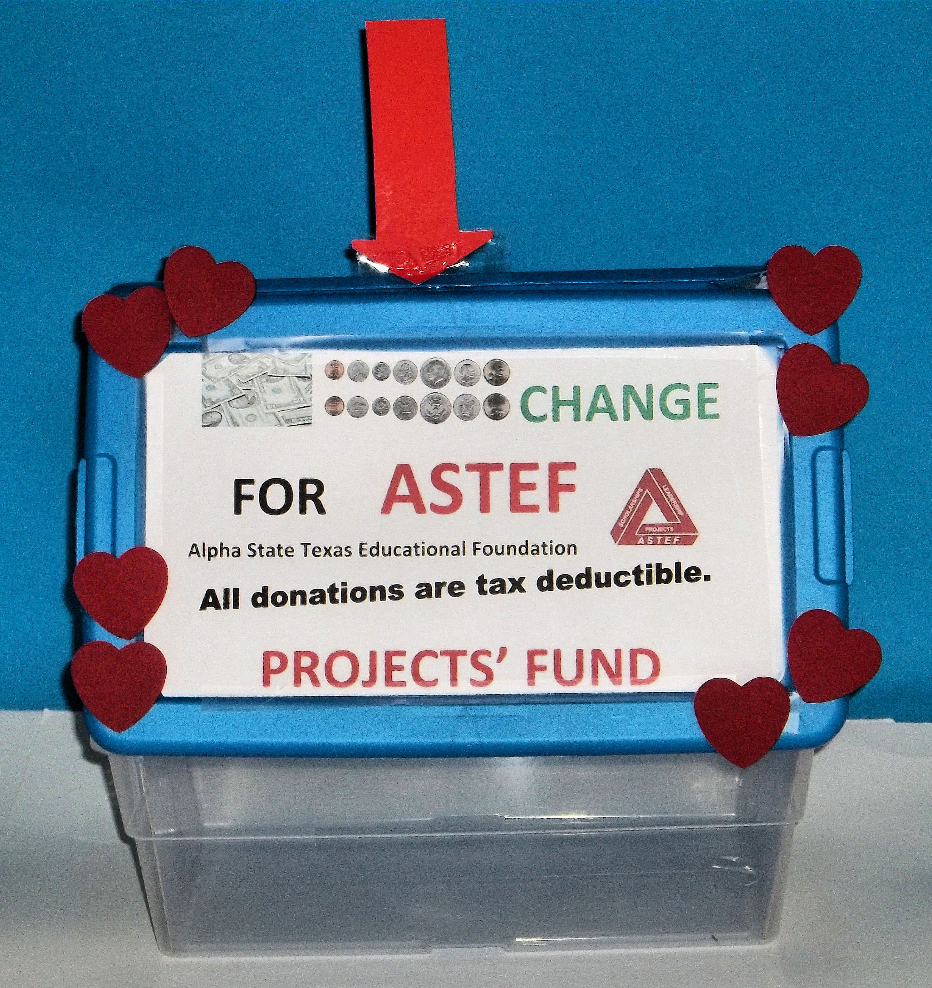

Prior to February, Theta Sigma had begun collecting “Change for ASTEF”. The change would be donated in 2014 to the ASTEF Projects Fund.

The presentation opened by highlighting the ASTEF funds that benefited Delta Kappa Gamma members and chapters in Texas: Scholarships, Leadership Training, and Projects. Throughout the years Theta Sigma members have received state scholarships and some have participated in the Texas State Leadership Seminar.

The second part of the ASTEF February Foundation Focus presentation emphasized the newest fund that is available for chapter stipends that support local projects. The chapter had never received a project stipend. Over the years, however, Theta Sigma members have actively participated in a variety of chapter projects. Using this experience as a foundation, members discussed what type of project might more significantly impact the needs of Texas students and women educators. Several suggestions were made about different approaches to the book projects and the teacher mentoring projects.

As follow-up to the program, Theta Sigma members committed to applying for a project stipend in the coming year. The chapter’s vision is that by securing an ASTEF stipend, the chapter will better serve the professional and personal needs of women educators and will strengthen the interest of Texas students in achieving educational excellence.

The program ended with a song found on the TSO Website / ASTEF / Resources / Foundation Focus ideas.
Tune: Row, Row, Row, Your Boat (A Round)
A-S-TEF funding we pursue
For Leadership, Scholarships, Projects, and
Personal growth for you.

Katherine L. Reid
ASTEF Board Member
Theta Sigma Chapter
Area 3

