

Alpha State Texas Educational Foundation

Throughout this coming year, local chapters will be focusing on ASTEF, Alpha State Texas Educational Foundation, during chapter meetings. The ideas you may need are right here.

From songs to games to icebreakers, to scripts, to slogans and much more, the resources are here for your convenience!

Begin Planning Now

Your focus does not have to be a lengthy program. Try some short activities that are suggested below to help your members better understand ASTEF and how ASTEF benefits members across the state.

Let’s start with a short introduction to your ASTEF focus.

- Introduction - Addendum, pg. 3
- ASTEF Brochure - Addendum, pg. 4-5
- ASTEF and/or TSO? Quiz - Addendum, pg. 6
- Answers to the quiz – Addendum, pg. 7
- Your own introduction – Make it up!

Now add some ideas for catchy songs.

- Songs - Addendum, pg. 8
- Your very own song – Make it up!

Next include raps about ASTEF.

- Raps – Addendum, pg. 8
- Your chapter’s own rap – Be creative!

Create some slogans or Burma Shave Signs.

- Sample slogans - Addendum, pg. 9
- Sample Burma Shave Signs - Addendum, pg. 9
- Your chapter’s creations - Help your members create different slogans and/or Burma Shave Signs and consider sharing these with the ASTEF Marketing team, marketing@astef.org

After your brief introduction, have members complete a crossword puzzle about ASTEF.

- Crossword puzzle - Addendum, pg. 10; Answers, pg. 11
- Your chapter’s crossword puzzle – Challenge members to create a new ASTEF crossword puzzle.

Consider a banner for your chapter newsletter.

- Sample banner ideas - Addendum, pg. 11
- Your chapter’s banner – Participate in a contest to create your chapter’s banner.

Prepare a news release for your chapter. Submit the article and action photos to the local media: cable, television, radio--school and city.

- Sample News Release – Addendum, pg. 12
- Your chapter’s news release - Create a news release for the local media: city or school. Walk it to the editor’s office and introduce yourself and your chapter.

Share The Good News. - Addendum, pg. 12
- Photograph members in action during your chapter’s special awareness program focusing on ASTEF’s programs and activities. . Share these with your members and local media.
- Write up successful activities and send these to the ASTEF marketing team, Katherine Reid, chair, marketing@astef.org. With your permission, we would like to spread your ASTEF News.
- Remind members that contributions to ASTEF are tax deductible to the extent allowed by law.
- Contribution Form – Addendum, pg. 15

Use laser speeches to help spread the word.

- Sample Laser Speeches - Addendum, pg. 12-14

Have a Great Year!
Your ASTEF Friends

ADDENDUM

*** Any page in this packet may be printed for your convenience by right clicking on the page, clicking on “print” and then asking the printer to print that specific page by its page number.

INTRODUCTION

Members of the Foundation

All members of the Texas State Organization of Delta Kappa Gamma are members of ASTEF. The Annual Meeting of members is held during the TSO Convention. ASTEF is managed by a Board of Directors.. The 2015-2017 Board consists of nineteen elected Directors and four Directors ex-officio. Ex-officio Directors include the TSO President, TSO Exec Sec/Treas, TSO Scholarship Chair and TSO Leadership Chair. Officers are elected by the Board of Directors.

Member Benefits

ASTEF manages funds that provide for Scholarships, Leadership Training, and Projects.

Scholarship funds provide for scholarships and lifelong learning opportunities.

Leadership funds provide for leadership training through Leadership Seminars and sponsored speakers.

Projects funds provide for stipends for projects as well as other educational endeavors that benefit Texas students and educators such as the Aspiring Educator Award.

The Aspiring Educator Award aids women, who are not members of The Delta Kappa Gamma Society International, who aspire to enter the field of education by taking college hours toward certification for a degree in education. Applicants must be recommended by a Society member.

ASTEF members may apply for a TSO state scholarship; participate in leadership events sponsored by ASTEF; and apply for a chapter project stipend.

ASTEF Support

As a 501(c)(3) public charity, ASTEF provides funding for activities that support professional and personal growth of women educators in Texas and promotes educational excellence for Texas students.

ASTEF raises funds to support the Texas State Organization of Delta Kappa Gamma. Members and guests may participate in ASTEF fundraising activities, such as cruises, Road Scholar programs, and raffles.

Contribution forms are available online for your convenience in giving. Donations may be made in honor or in memory of someone. All contributions are tax deductible to the extent allowed by law.

(Contribution Form - Addendum, pg.15.
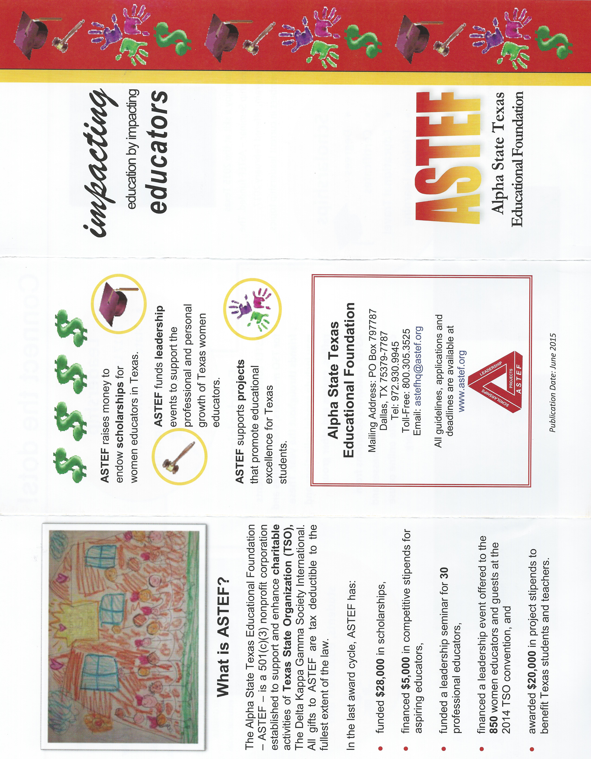

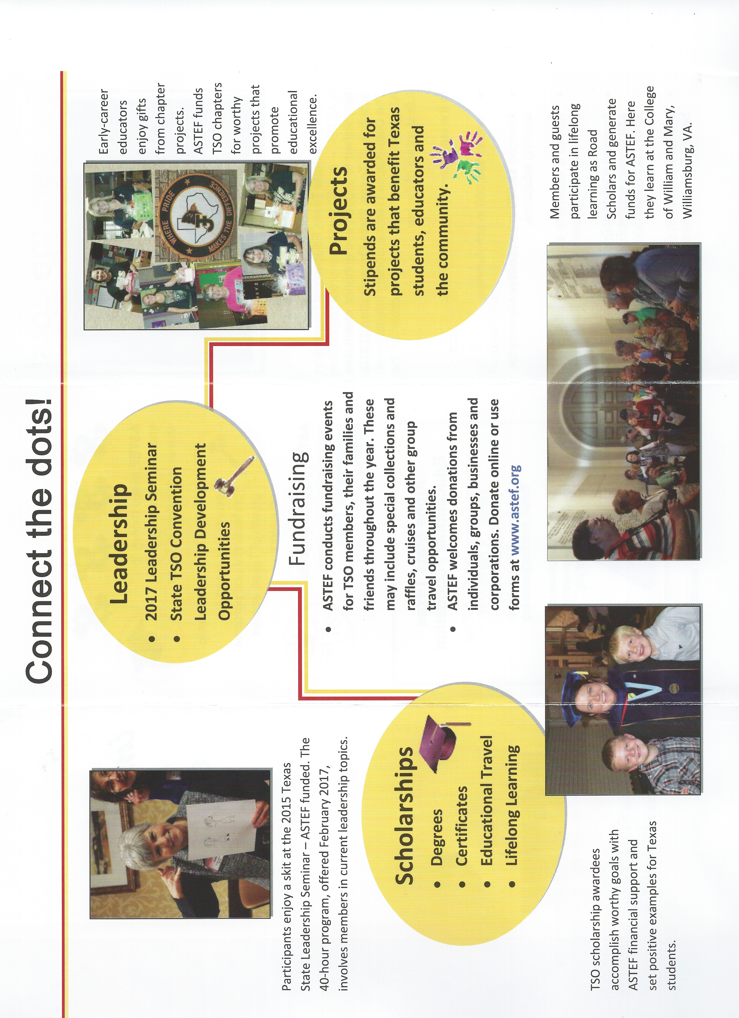

After sharing information about ASTEF with your members, have them try the following exercise to see if they’re able to identify the relationship between TSO and ASTEF.


ASTEF
ALPHA STATE TEXAS EDUCATIONAL FOUNDATION

TSO
TEXAS STATE ORGANIZATION

Where does each statement best fit? Put it in the box.

CHARACTERISTICS | TSO | ASTEF
Leading Women Educators Impacting Education Worldwide
Impacting Education by Impacting Educators
Implements 7 Purposes
Collects dues
Accepts contributions for scholarships
Accepts contributions for leadership development
Accepts contributions for projects
Accepts contributions to the Eula Lee Carter Memorial Fund
Accepts contributions that are tax deductible
Conducts the Texas State Leadership Seminar
Determines scholarship recipients
Determines Eula Lee Carter Memorial Fund award recipients
Funds the Texas State Leadership Seminar
Funds the awarded scholarships
Funds Eula Lee Carter Memorial Fund awards
Funds multiple chapter projects
Conducts multiple fundraising activities
Prepares a budget
Managed by a Board of Directors
Governed by an Executive Board
Holds a business meeting for all members at state convention
Owns the state headquarters building
IRS status is 501(c)(3) nonprofit public charity
IRS status is 501(c)(6) nonprofit professional organization
Has approximately 9,000 members in Texas
Originator and older
I am a member of
Provides funding for activities that support professional and personal growth of women educators in Texas and promotes educational excellence for Texas students

ANSWERS:

CHARACTERISTICS | TSO | ASTEF
Leading Women Educators Impacting Education Worldwide | X
Impacting Education by Impacting Educators |  | X
Implements 7 Purposes | X
Collects dues | X
Accepts contributions for scholarships |  | X
Accepts contributions for leadership development |  | X
Accepts contributions for projects |  | X
Accepts contributions to the Eula Lee Carter Memorial Fund | X
Accepts contributions that are tax deductible |  | X
Conducts the Texas State Leadership Seminar | X
Determines scholarship recipients | X
Determines Eula Lee Carter Memorial Fund award recipients | X
Funds the Texas State Leadership Seminar |  | X
Funds the awarded scholarships |  | X
Funds Eula Lee Carter Memorial Fund awards | X
Funds multiple chapter projects |  | X
Conducts multiple fundraising activities |  | X
Prepares a budget | X | X
Managed by a Board of Directors |  | X
Governed by an Executive Board | X
Holds a business meeting for all members at state convention | X | X
Owns the state headquarters building | X
IRS status is 501(c)(3) nonprofit public charity |  | X
IRS status is 501(c)(6) nonprofit professional organization | X
Has approximately 9,000 members in Texas | X | X
Originator and older | X
I am a member of | X | X
Provides funding for activities that support professional and personal growth of women educators in Texas and promotes educational excellence for Texas students |  | X

SONGS

Challenge members to make up a song or rap about ASTEF. ASTEF bookmarks could be prizes for their efforts. Ask them to do so before or after the ASTEF program in February.

Tune: Row, Row, Row Your Boat
A-S-TEF funding we pursue
For Leadership, Scholarships, Projects, and
Personal growth for you.

Tune: Are You Sleeping?
Are you grumpy, feeling frumpy
Put some style in your smile
Make a big donation to ASTEF Foundation
You'll feel good, like you should

Tune: And Bingo Was His Name O
This is the month we recognize
with great anticipation
A-S-TEF, A-S-TEF-A-S-TEF
Our DKG Foundation

Icebreaker:
Lead the group using the B-I-NGO beat used in the ditty: B-I-NGO, B-I-NGO, Bingo and Bingo was his Name O but instead say:
A-S-TEF, A-S-TEF, ASTEF and ASTEF ______________
Have members fill in or shout out endings such as:
1) is a non-profit 501(c)(3)
2) our fundraising entity
3) has no dues
4) members are TSO members
5) supports scholarships for TSO educators
6) provides funds for the TSO Leadership Seminar
7) awards grants to chapters for unique projects to promote excellence in education and Texas students
8) etc.
RAPS

RAP 1:
What do you know it's the new sensation
The latest news in education
For projects, scholarships and leadership too
Learn what ASTEF can do for you!

SLOGANS
Create a jingle that would promote ASTEF, just like a slogan for most products.
Samples:
- Sharing our Resources, Supporting From Within (Projects and Scholarships)
- Make the News, Make a Donation (Fundraising - Raffles, etc.)
- Join the Adventure (ASTEF Sponsored Trips)

BURMA SHAVE SIGNS

Alpha State Texas Educational Foundation
Chapter projects we adore:
Books, technology apps, classroom supplies, and mentors--our core.
ASTEF.
______________________________________________________________________
Early career educator/Now can rest
She has a mentor/One of the best
Supported by/ASTEF Project Funds
______________________________________________________________________
Your chapter budget/Has had its day
So why not choose the modern way
Apply for ASTEF Funds/Okay?

Involve members/Improve teaching
Enhance excellence/Students reaching.
Apply for an ASTEF Stipend

Teachers pleading/Students needing
Stop/Avoid the picket.
Buy a raffle ticket/ASTEF.
______________________________________________________________________
Scholarship/Leadership
Projects/Reflect
ASTEF Funds
______________________________________________________________________
Raffles/Cruises
Gifts/No bruises.
ASTEF Fundraising
______________________________________________________________________
Degrees/Certificates/Life-long Learning
Enrichment/ Professional Advancement: stop the yearning.
Apply for a TSO Scholarship/ASTEF funded.
______________________________________________________________________
Potential to lead/ Service to cede/
Friends to make on a short winter break.
Texas State Leadership Seminar/ASTEF funded.

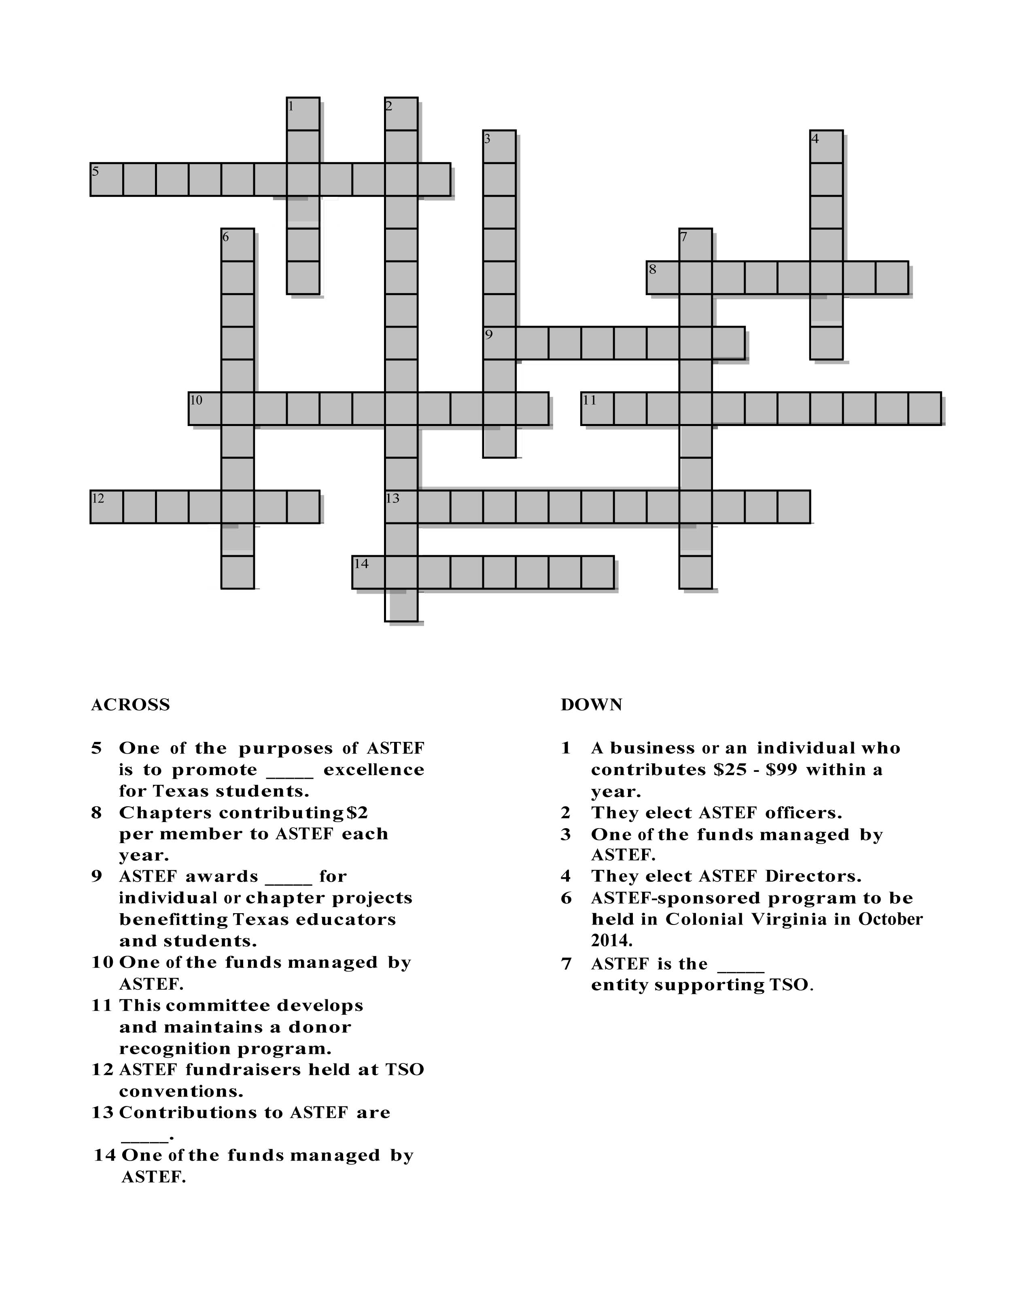
PUZZLES / GAME
_________travel programs support
ASTEF fundraising.

ANSWERS:

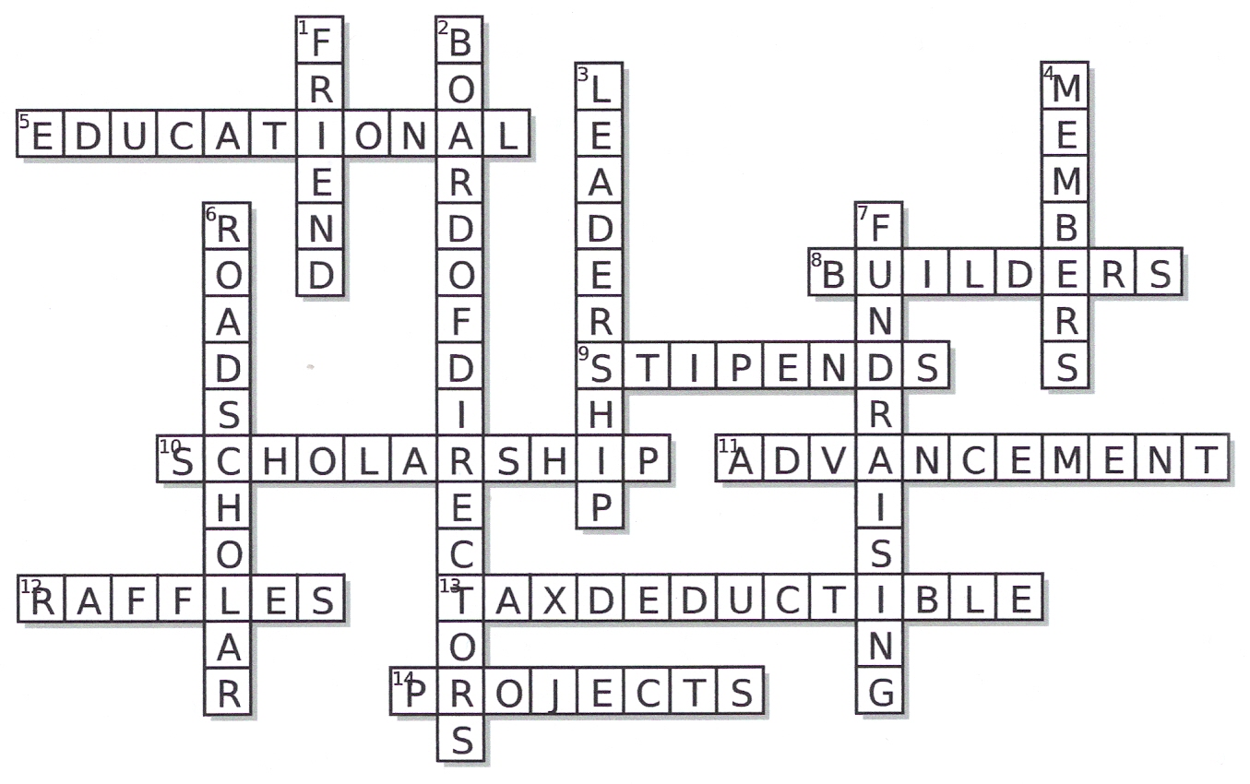

BANNERS FOR CHAPTER NEWSLETTERS
November: ASTEF funds leadership opportunities. Don't miss one at the next state convention.
December: ASTEF funds projects that impact Texas students. Apply by April 1.
January: ASTEF brings you New Year Greetings! Impacting Education by Impacting Educators
February: ASTEF challenges you to find games, icebreakers and other information on the ASTEF web page, astef.org, under Foundation Focus Ideas to use for chapter awareness of ASTEF programs and activities.
March: ASTEF recognizes your gift at state convention! Please submit by April 1!
April: ASTEF suggests a travel adventure for you! Register now!
May: ASTEF funds ___# scholarships for TSO members. Grand total: $ ____
June: ASTEF announces projects at its annual meeting! Be there!
July: ASTEF celebrates you as a donor! Thank you so much!
August: ASTEF project participant _______ describes the impact of a unique opportunity for Texas students in the Lone Star News. Read the details in the Fall issue.
September: ASTEF scholarship recipient ___________ reports her learning experience as _____. Find details ______.
SAMPLE NEWS RELEASE

A special program was presented by _____________(insert name of chapter) on
________ (insert date) which focused on the Alpha State Texas Educational Foundation (ASTEF), a charitable organization that benefits education, educators and students within the state of Texas. Through ASTEF, Delta Kappa Gamma members are able to apply for leadership training, scholarships and special project stipends that benefit educators, students and charitable organizations in the community. ASTEF is a 501(c)(3) organization and all donations are tax deductible to the extent allowed by law. ASTEF also sponsors travel opportunities for Delta Kappa Gamma members which benefit the funds within the organization. More information on ASTEF is available at www.astef.org.

Those (insert chapter name) members participating in the program include (insert names and some local information about each).

SHARING THE GOOD NEWS

Please consider sharing your chapter’s good ASTEF news with the events/marketing team that provided these ideas for your chapter’s ASTEF program planning. Send news and photos to Katherine Reid, Marketing chair, marketing@astef.org.
By sending pictures or news, you are giving permission for us to publish these in the Lone Star News, on the TSO website and in Constant Contact e-mail messages to ASTEF members..

LASER SPEECHES TO HELP SPREAD THE WORD

During the year, ASTEF promoted excellence in education by funding scholarships, leadership training, and projects impacting Texas children.

Thank you for your contribution!

Members in all counties of Texas are interested in continuing this great start by investing more in a variety of projects to encourage students and educators across Texas. These projects will include:
- Support for Early-Career Educators (attrition rate is 3-5 years)
- Leadership development for women (the number of women as heads of households continues to increase)
- A more equitable education for Texas students (families struggle to give their children an affordable education)

You can help by making a tax deductible contribution to ASTEF.
Expect to hear about our projects in July!

Who are we? We are professional educators who have been honored with membership in Texas State Organization, Delta Kappa Gamma.
What do we do? We raise funds for activities to promote educational excellence for Texas students and support professional and personal growth of women educators in Texas.
What is our focus? Our focus is scholarships, leadership development, service projects, and stipends to Aspiring Educators. ASTEF

We raise money for scholarships for women educators in Texas.
We fund leadership events to support the professional and personal growth of Texas women educators.
We support projects that promote educational excellence for Texas students.
We fund stipends for Aspiring Educators. ASTEF

We raise funds to promote educational excellence for Texas students. We provide funding to support the professional and personal growth of women educators in Texas. We raise money for scholarships, leadership events, projects and Aspiring Educators. ASTEF

Raising funds for activities to promote educational excellence for Texas students is what we do. Individually we were invited to membership in Texas State Organization, Delta Kappa Gamma, and work to promote funding for the professional and personal growth of Texas women educators. We focus primarily on a variety of scholarships, leadership opportunities, special projects and stipends for Aspiring Educators. Our fundraising activities include raffles, auctions, cruises and other campaigns to build funds to sustain our scholarships, leadership events, multiple projects and Stipends to Aspiring Educators. Members and guests have cruised the Eastern Caribbean and Alaska. In 2014, ASTEF sponsored a Road Scholar trip to Williamsburg. In 2015, ASTEF will travel to Savannah, GA. You can join us on this upcoming travel adventure. Details appear on the website: astef.org ASTEF

We are the fundraising arm of Texas State organization, Delta Kappa Gamma, educational honor society of women members represent all levels of education. We promote funding for activities that support professional and personal growth of women educators in Texas and promote educational excellence for Texas students. We offer scholarships, train leaders, fund projects in communities across the state and supply stipends to Aspiring Educators. ASTEF

This space is reserved for you!

Facts to work with:

In the past year, ASTEF and/or ASTEF’s Board Members:

- Presented an ASTEF Celebration at the San Antonio convention. ASTEF is five (5) years old. HIGH FIVE ASTEF!
- Funded $28,000 in scholarships, plus $5,000 for Aspiring Educators.
- Financed 18 competitive stipends to educators in Texas. Over $20,000 in stipends were awarded in San Antonio.
- Funded an intensive Leadership Seminar for professional educators
- Raised over $20,000 in funds through a “Piggy Bank Posse” project throughout the state
- Attended each of the 18 Area Workshops in Texas to share information about ASTEF.
- Sponsored a Road Scholar travel program to Colonial and Revolutionary Virginia and began plans for an upcoming 2015 Road Scholar trip to Savannah, GA.
- Created a new website – www.astef.org.
- Shared ASTEF news with members through Constant Contact e-mail messages, the Lone Star News, and a News section of the ASTEF website, www.astef.org.
- Received approval for ASTEF to assume responsibility for administering and funding the Aspiring Educator program.
- Conducted the first Orientation for incoming ASTEF Board Members.
- Recognized ASTEF donors in the convention program and through personal contacts.
- Elected new ASTEF officers for the upcoming biennium. (Elected by ASTEF Board of Directors).
- Elected new ASTEF Directors (Elected by ASTEF members at the ASTEF annual meeting).



